
THE POSTS AND TELECOMMUNICATIONS INSTITUTE OF TECHNOLOGY
DEPARTMENT OF INFORMATION TECHNOLOGY 1

DEPARTMENT OF INFORMATION TECHNOLOGY 1

MODULE: CUSTOMER PAYING
REPORT: SUMMARY REPORT

FINAL REPORT

Class | : | E22CQCN03-B
Course group | : | Group 6
Group topic | : | Mini football field management
Project group | : | Group 12
Group members | : | trần minh hiếu – B22DCCN320  Nguyễn Việt Hoàng – B22DCVT214  nguyễn tuấn minh – B22DCKH077  bùi minh tùng – B22DCDT293

Hà Nội - 2025

1. Detail Use Case diagram for module 3: Customer paying

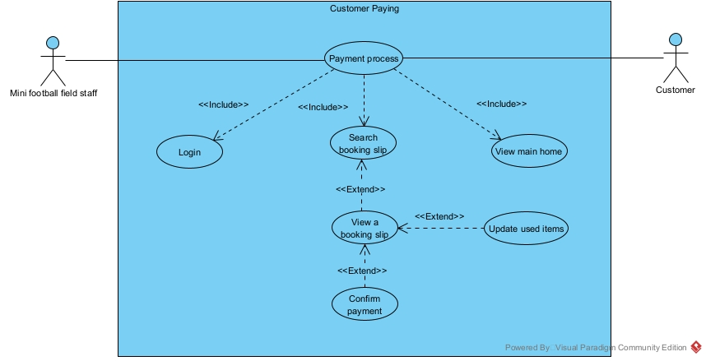
- Description:
- Login: This use case let the mini football field staff log in to the system
- View main home page: This use case let the mini football field staff choose the function that the staff can access
- Payment process: This use case let the mini football field staff use the payment process function
- Search booking slip: This use case let the mini football field staff search the booking slip by the current customer information
- View a booking slip: This use case let the staff view the correct booking slip with the provided customer’s information
- Update used items: This use case let the mini football field staff change or update the detailed list of the used items in case the customer complains
- Confirm payment: This use case let the mini football field staff confirm that the payment for the booking slip has been made

2. Standard scenario of the module
Scenario | Update Used Items of the rental session
Actor(s) | Receptionist, Customer
Pre-condition | Receptionist has a receptionist account
Post-condition | - The payment for the session is saved in the database  - The detailed list of the used items of the session is updated if the customer has a complain
Main-events | 1. The receptionist A open the app to process the payment for the rental session of the customer B  2. The system display a login interface with a field to enter username, a field to enter password and a Login button  3. The receptionist enter username = “a”, password = “a” and click Login  4. The system display the main interface with the option to process payment  5. The receptionist click on the option to process payment  6. The system displays the search for customer with the input of customer name  7. The receptionist ask the customer about their name  8. The customer answer that their name is An  9. The receptionist enter the name “an” + click search  10. The system show the result interface  Search Customer  Go Back  Customer name:  An  Search  Id Name Address Phone Email Note  1 An Huynh Thuc Khang 9172386245 an@gmail.com  2 Anh Lang Ha 1234685647 anh@gmail.com  11. The receptionist ask the customer about their phone number  12. The customer answer with 9172386245  13. The receptionist click on the row of the correct customer  14. The interface shows a list of booking ticket with that customer name  Booking Tickets for Customer: An  Go Back  id dateOfContract depositAmount  1 30/03/2024 0  3 20/06/2024 0  15. The receptionist ask the customer which booking slip they want to make payment for  16. The customer answer the one with date of contract of 30/03/2024  17. The receptionist clicks the row of the booking ticket with the correct date of contract  18. The system shows the interface  Invoice  Confirm  Go Back  Customer Information  Name: An  Phone: 9172386245  Email: an@gmail.com  Field Cost  Court Court type Sessions Total Cost  1 single 13 6,500,000 VND  2 single 1 500,000VND  Items used  Session Item Name Quantity Price  1 Pepsi 10 100000  1 Revive 5 50000  2 Revive 5 50000  Field Cost 7,000,000 VND  Items Cost 200,000VND  Total 7,200,000VND  19. The customer confirm the information in the invoice, paid the money and the receptionist click the confirm button  20. The system display a confirm box, with a field to enter payment method, a confirm button and a cancel button  Payment Confirmation  Payment Method:  Cancel  Confirm  21. The receptionist enter the payment method and click confirm button  22. The system display a success alert, confirming that the payment have been successfully save into the database and then returns to the main interface
Exception | 4. The system display a “Login failed” alert and a Confirm button  4.1. The receptionist click the Confirm button  4.2. The system show the login interface  4.3. The receptionist enter the username and password correctly  4.4. The system display the main interface  19. The customer has a complain about this list of items used in the session  19.1. The receptionist click on an item that the customer complain about  19.2. The system show a pop-up interface with the name of the item, a field to enter that item quantity, and a Confirm button  Update Item Quantity  Item Name: Pepsi  New quantity:  Confirm  Back  19.3. The receptionist enter the number that item base on the customer’s complain and click Confirm  19.4. The system close the pop-up interface, and the invoice is update with the item’s new quantity  19.5. The receptionist then repeat step 19.1. to 19.4. for all the item that the customer complain about
3. Entity class diagram of analysis phase of the module
- Step 1: Describe the system in a paragraph or a scenario + exceptions
- Step 2+3: Extract and evaluate nouns in Step 1
+ Receptionist => Need to be managed => Class User: fullName, username, password, role
+ Customer => Need to be managed => Class Customer: name, address, phone, email, note
+ Account => Too generic => Eliminate
+ Session => Need to be managed => Class Session: receptionTime, returnTime, duration, status, note
+ Database => Too generic => Eliminate
+ Item => Need to be managed => Class Item: name, price, amount,
unit, category
+ Invoice => Need to be managed => Class Invoice: paymentDate,
paymentMethod, totalAmount
+Court => Need to be managed => Class Court: type, price
+ System => Too generic => Eliminate
+ Interface => Too generic => Eliminate
+ Button => Too generic => Eliminate
+ Rental period => Too generic => Eliminate
+ Booking ticket => Need to be managed => Class BookingTicket: dateOfContract, depositAmount, startHour, endHour
+ Alert => Too generic => Eliminate
=> Class extracted: User, Customer, Session, BookingTicket, Invoice, Item, Court
- Step 4: Consider quantities relationship among classes
+ 1 booking ticket has 1 customer, 1 customer can have 0 or many booking ticket => 1-n relationship
+ 1 session can have 0 or many items used, 1 item can be used in 0 or many session => n-n relationship => Create class UsedItem
+ 1 user can make 0 or many invoice, 1 invoice can be made by only 1 user => 1-n relationship
+ 1 booking ticket has 1 invoice, 1 invoice belongs to 1 booking ticket => 1-1 relationship
+ 1 booking ticket can be made by 1 user, 1 user can make many booking ticket => 1-n relationship
+ 1 booking ticket can book many courts, 1 court can be booked in many booking ticket => n-n relationship => Create class BookedCourt
+ 1 booked court can has many session, 1 session belongs to 1 booked court => 1-n relationship
+ 1 invoice can only have 1 customer, 1 customer can have many invoice => 1-n relationship
+ 1 BookedCourt can have many session, 1 session can only belong to 1 bookedCourt => 1-n relationship

- Step 5: Determine the object relationship among entity classes

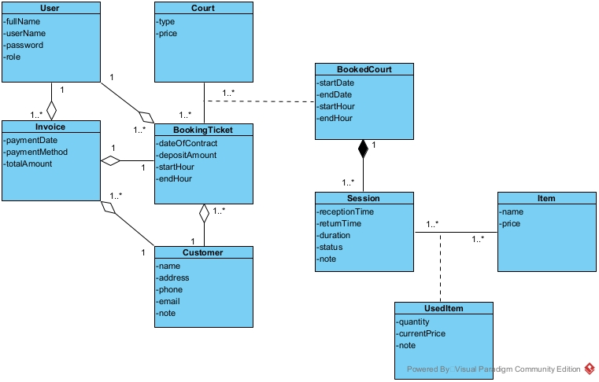
4. Full class diagram of analysis phase of the module
- When the receptionist open the app, the system display a login interface => LoginView:
+ Input for username: inUsername
+ Input for password: inPassword
+ Login button: subLogin
- When click the login button, the system check username and password => a function:
+ Name: checkLogin()
+ Input: username, password
+ Output: boolean
+ Owner class: User
- The system displays the main interface => Class MainHomeView:
+ With at least an option Customer paying => subCustomerPaying
- Click on Customer Paying, the interface to search for customer by name appears => Class SearchCustomerView:
+ Input customer name: inName
+ Search button: subSearch
+ List of customer: outsubListCustomer
- Click on search button to search customer by name => a function:
+ Name: searchCustomer()
+ Input: Customer name
+ Output: List of customer
+ Owner class: Customer
- Click on a customer to show their booking ticket => a function:
+ Name: getBookingTickets()
+ Input: An object of customer
+ Output: List of booking ticket from a customer
+ Owner class: BookingTicket
- Click on a customer, the interface to show the list of booking ticket appears => Class BookingTicketView:
+ List of booking ticket: outsubListBookingTicket
- Click on 1 booking ticket, the interface with the invoice with full customer information and detailed list of items used in the session appear => Class InvoiceView :
+ Confirm the payment: subConfirm
+ List of used item that can be changed: outsubListUsedItem
+ Invoice with full customer information: outInvoice
- Click on 1 item, the interface to change item quantity appear => Class ChangeItemNumberView:
+ Input : inNumber
+ Confirm button: subConfirm
+ Cancel button: subCancel
- When click confirm to change item quantity, the system update the invoice in the system => a function:
+ Name: updateUsedQuantity()
+ Input: The number of an item, an object of item
+ Output: Void
+ Owner class: Session
- Click on confirm to update the payment => a function:
+ Name: saveInvoice()
+ Input: an object of invoice, a string for payment method, an object of user
+ Output: boolean
+ Owner Class: Invoice
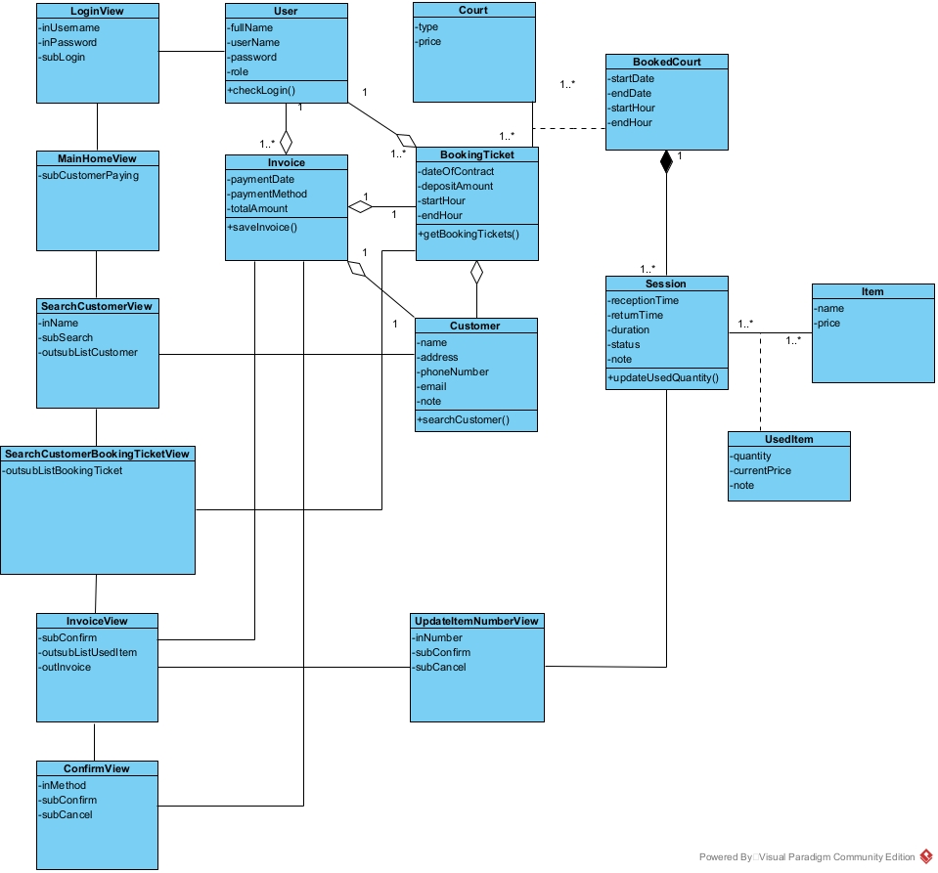
5. Sequence diagram of analysis phase of the module
- Receptionist open the app, input username and password and click login in class LoginView
- Class LoginView calls class User
- Class User use checkLogin() to verify the log in. Log in success
- Class User return the result to class LoginView
- Class LoginView calls class MainHomeView
- Class MainHomeView displays itself to the receptionist
- The receptionist clicks subCustomerPaying button to use function “Customer paying”
- Class MainHomeView calls class SearchCustomerView
- Class SearchCustomerView displays itself to the receptionist
- The receptionist asks the customer for their name
- The customer says their name
- The receptionist enter the customer name and click search
- The class SearchCustomerView calls class Customer
- Class Customer use searchCustomer() to find the list of customer
- Class Customer return the result to the class SearchCustomerView
- Class SearchCustomerView displays the list of customer to the receptionist
- The receptionist asks the customer for their phone number
- The customer says their phone number
- The receptionist finds and clicks on the customer with the correct information
- The class SearchCustomerView calls the class BookingTicketView
- The CustomerBookingTicketView call the class BookingTicket
- The class BookingTicket use function getBookingTickets() to find the list of a customer booking tickets
- The class BookingTicket return the result to the BookingTicketView class
- The class CustomerBookingTicketView displays itself along with the list of booking tickets from a customer to the receptionist
- The receptionist ask the customer which booking ticket they want to make payment for
- The customer response with the period of the correct booking ticket
- The receptionist clicks on the correct booking tickets from the list
- The class CustomerBookingTicket calls the class InvoiceView
- The class InvoiceView display itself along with the invoice
- The receptionist then asks the customer to confirm the invoice and make payment
- The customer confirms and pays for the invoice
- The receptionist then clicks confirm
- The class InvoiceView calls class ConfirmView
- The class ConfirmView displays itself to the receptionist
- The receptionist enter payment method and clicks Confirm
- The class ConfirmView calls class Invoice
- The class Invoice use function saveInvoice()
- The class Invoice return to the class ConfirmView
- The class ConfirmView displays a success message to the receptionist
- The receptionist click “OK” in the message
- The class ConfirmView call class MainHomeView
- The class MainHomeView displays itself to the receptionist
- The receptionist informs the successful payment to the customer
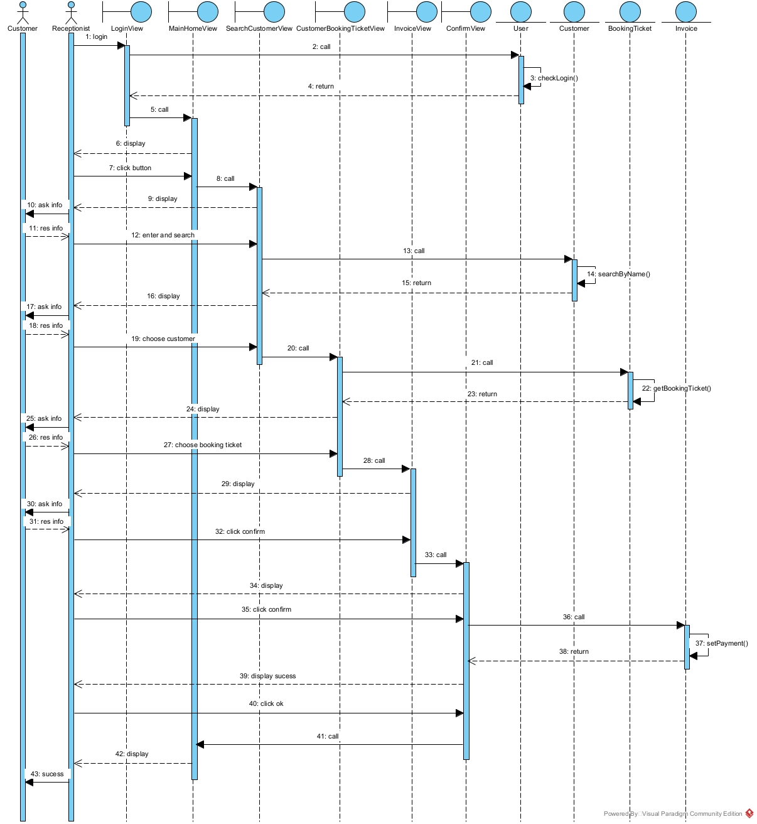
Exception:
3. The method checkLogin() return false:
3.1. Class User return the result to LoginView
3.2. LoginView show the alert “Wrong user name or password”
3.3. The receptionist enter user name and password correctly and click Login button
3.4. The MainHomeView is shown to the receptionist
30. The customer want to change an item quantity
30.1. The receptionist click on the item used in the session that the customer complain
30.2. UpdatedItemNumberView is shown to the receptionist
30.3. The receptionist enter the new number and click OK button
30.4. The InvoiceView is shown to the receptionist
6. Entity class design of the module
- Step 1: Add the id attribute for the classes which DO NOT inherit from other class Court, BookedCourt, BookingTicket, Customer, User, Session, UsedItem, Item, Invoice.

- Step 2: Add the type of each attribute in all classes:
- User:
  - fullName: String
  - username: String
  - password: String
  - role: String
- Invoice:
  - paymentDate: Date
  - paymentMethod: String
  - totalAmount: int
- BookedCourt:
  - startDate: Date
  - endDate: Date
  - startHour: Time
  - endHour: Time
- Court:
  - type: String
  - price: int
- BookingTicket:
  - dateOfContract: Date
  - depositAmount: int
- Customer:
  - name: String
  - address: String
  - phone: String
  - email: String
  - note: String
- Session:
  - receptionTime: Time
  - returnTime: Time
  - duration : Time
  - date: Date
- Item:
  - name: String
  - price: int
- UsedItem:
  - quantity: int
  - currentPrice: int

- Step 3: Convert all association relationships to correspond aggregation/ composition relationships:
BookingTicket + Court-> BookedCourt is converted to: Court is a component of BookedCourt, BookedCourt is a component of BookingTicket.
Session + Item-> UsedItem is converted to: Item is a component of UsedItem, UsedItem is a component of Session.

- Step 4: Add the object attributes which correspond to the aggregation/composition relationships:
- Court is a component of BookedCourt, of type 1-n -> BookedCourt has a Court
- BookedCourt is a component of BookingTicket, of type n-1 -> BookingTicket has a BookedCourt
- Customer is a component of BookingTicket, of type 1-n -> BookingTicket has a Customer
- Customer is a component of Invoice, of type 1-n -> Invoice has a Customer
- User is a component of BookingTicket, of type 1-n -> BookingTicket has an User
- User is a component of Invoice, of type 1-n -> Invoice has an User
- BookingTicket is a component of Invoice, of type 1-1 -> Invoice has an BookingTicket
- Item is a component of UsedItem, of type 1-n -> UsedItem has a Item
- UsedItem is a component of Session, of type n-1 -> Session has a list of UsedItem
- Session is a component of BookedCourt, of type n-1 -> BookedCourt has a list of Session
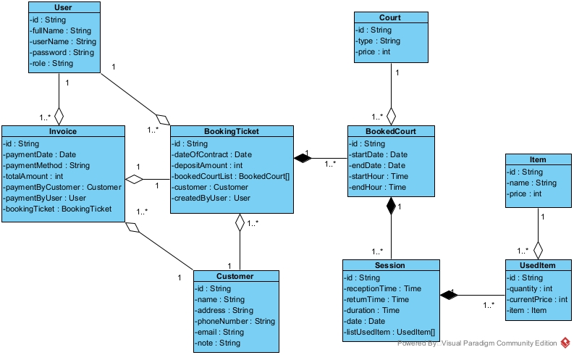

7. Database design of the module
- Step 1: For each entity class, create a corresponding table.
User -> tblUser
BookedCourt -> tblBookedCourt
Court -> tblCourt
Invoice -> tblInvoice
BookingTicket -> tblBookingTicket
Session -> tblSession
Item -> tblItem
Customer -> tblCustomer
UsedItem -> tblUsedItem

- Step 2: For each entity class, transfer all non-object attributes to contribute as the columns of the corresponding table.
- tblUser:
  - id: varchar(50)
  - fullName: varchar(50)
  - userName: varchar(50)
  - password: varchar(50)
  - note: varchar(50)
- tblBookedCourt:
  - id: varchar(50)
  - startDate: date
  - endDate: date
  - startHour: String
  - endHour: String
- tblCourt:
  - id: varchar(50)
  - type: varchar(50)
  - price: int
- tblInvoice:
  - id: varchar(50)
  - paymentDate: date
  - paymentMethod: varchar(50)
  - totalAmount: int
- tblBookingTicket:
  - id: varchar(50)
  - dateOfContract: date
  - depositAmount: int
- tblSession:
  - id: varchar(50)
  - receptionTime: varchar(50)
  - returnTime: varchar(50)
  - duration: varchar(50)
  - date: date
- tblItem:
  - id: varchar(50)
  - name: varchar(50)
  - price: int
- tblCustomer:
  - id: varchar(50)
  - name: varchar(50)
  - phoneNumber: varchar(50)
  - email: varchar(50)
  - note: varchar(50)
- tblUsedItem:
  - id: varchar(50)
  - quantity: int
  - currentPrice: int
  - note: varchar(50)

- Step 3: Consider the quantity relationships among entity classes. These relationships will be those among corresponding tables:
1 User – n BookingTicket
1 User – n Invoice
1 Customer – n BookingTicket
1 Customer – n Invoice
1 Invoice – 1 BookingTicket
1 Court – n BookedCourt
1 BookingTicket – n BookedCourt
1 BookingTicket – n Session
1 Session – n UsedItem
1 Item – n UsedItem

- Step 4: Configure the key column for tables.
- tblUser:
  - id: primary key
- tblBookedCourt:
  - id: primary key
  - The relationship between tblCourt and tblBookedCourt is 1-n -> tblBookedCourt will save the foreign key of CourtID references to tblCourt.
  - The relationship between tblBookingTicket and tblBookedCourt is 1-n -> tblBookedCourt will save the foreign key of BookingTicketID references to tblBookingTicket.
- tblCourt:
  - id: primary key
- tblInvoice:
  - id: primary key
  - The relationship between tblUser and tblInvoices is 1-n -> tblInvoices will save the foreign key of UserID references to tblUser.
  - The relationship between tblCustomer and tblInvoices is 1-n -> tblInvoices will save the foreign key of CustomerID references to tblCustomer.
  - The relationship between tblBookingTicket and tblInvoices is 1-1 -> tblInvoices will save the foreign key of BookingTicketID references to tblBookingTicket.
- tblBookingTicket:
  - id: primary key
  - The relationship between tblUser and tblBookingTicket is 1-n -> tblBookingTicket will save the foreign key of UserID references to tblUser.
  - The relationship between tblCustomer and tblBookingTicket is 1-n -> tblBookingTicket will save the foreign key of CustomerID references to tblCustomer.
- tblSession:
  - id: primary key
  - The relationship between tblBookedCourt and tblSession is 1-n -> tblSession will save the foreign key of BookedCourtId references to tblBookedCourt.
- tblItem:
  - id: primary key
- tblCustomer:
  - id: primary key
- tblUsedItem:
  - id: primary key
  - The relationship between tblItem and tblUsedItem is 1-n -> tblUsedItem will save the foreign key of ItemID references to tblItem.
The relationship between tblSession and tblUedItem is 1-n -> tblUsedItem will save the foreign key of ItemID references to tblItem.
- Step 5: Delete the derived attribute and abundant attribute
Abundant attribute: duration in in tblSession.
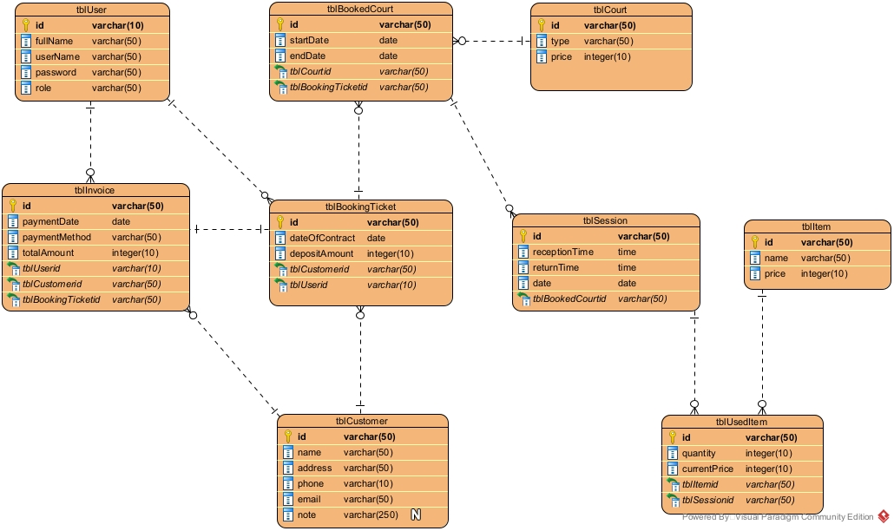
8. Interface design and full class diagram of the module
Interface design
In this module, the interface includes 7 main interface:
+ Login Page
+ MainHome Page
+ SearchCustomer Page
+ SearchBookingTicket Page
+ Invoice Page
+ Confirm Page.
+ UpdateItemNumber Page
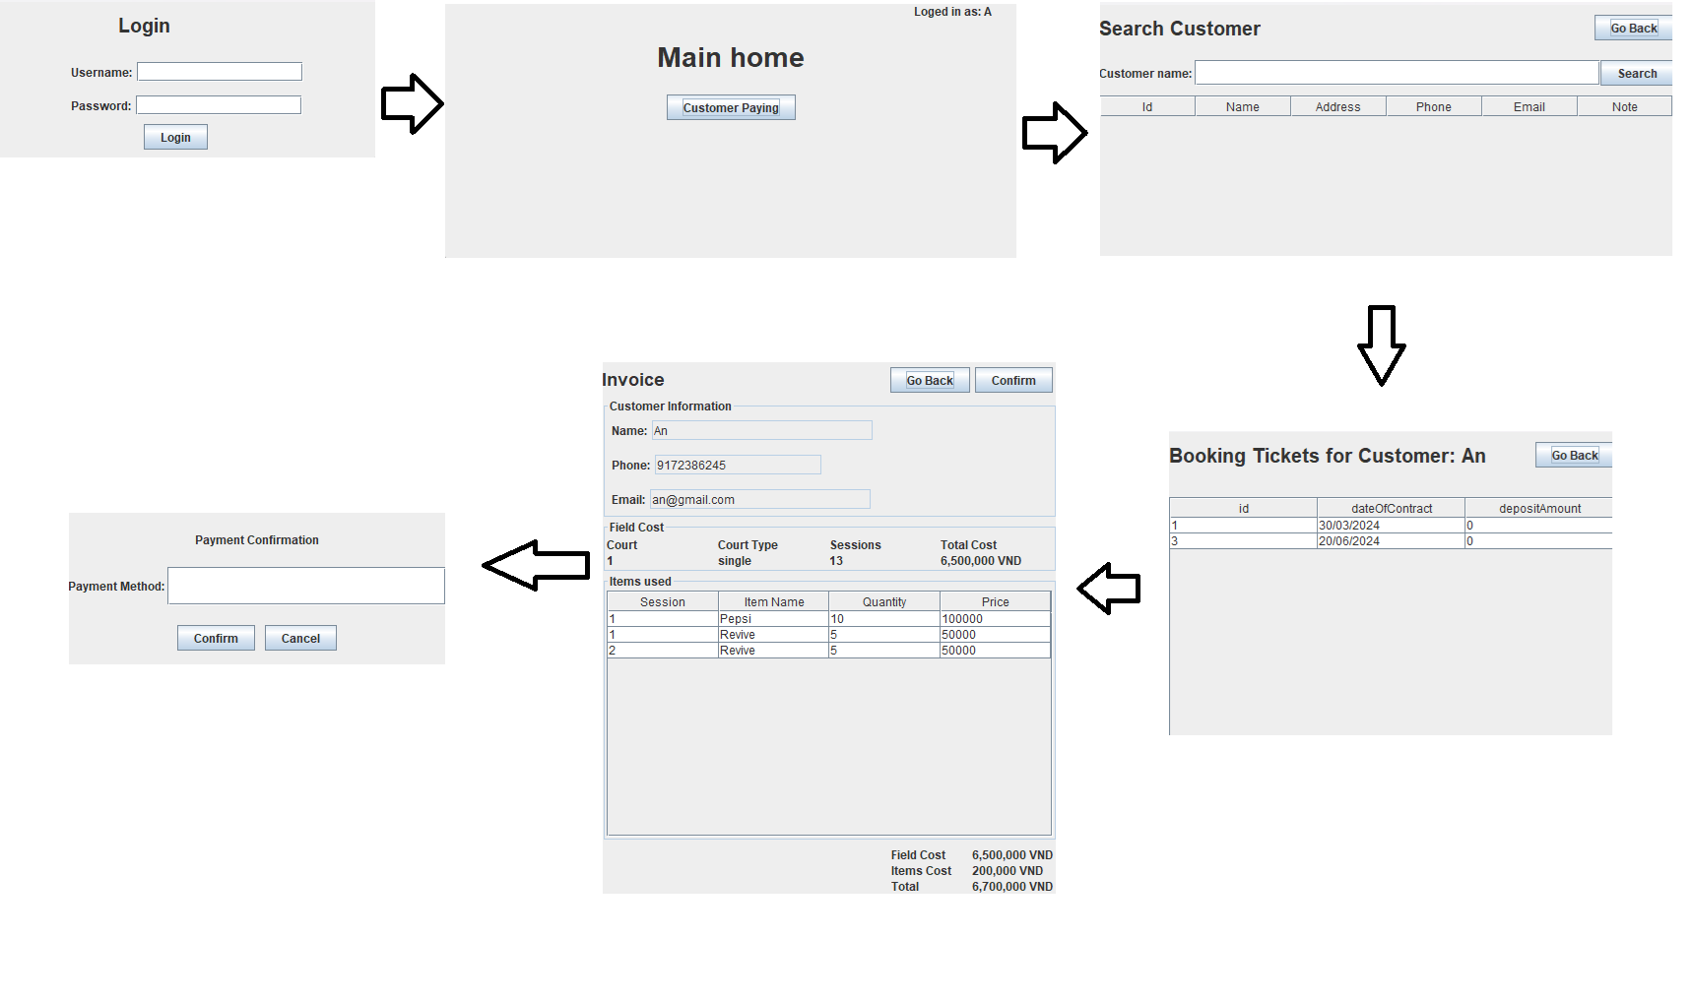
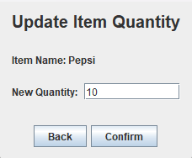
Full class diagram
View class
- LoginFrm is the interface to log in. It needs a text field to enter the username, a text field to enter a password, and a button to log in.
- MainHomeFrm is the home interface of the employee. It needs at least a button to go to the receptionist payment function.
- SearchCustomerFrm is the interface of searching customer. It includes a search button function, a text field to enter customer name and a table displaying list of all customer.
- SearchBookingTicketFrm is the interface of searching booking ticket. It includes a table displaying all booking ticket of a customer.
- InvoiceFrm is the interface of displaying invoice. It includes a button to confirm, a button to go back and a table displaying the list of used item.
- ConfirmFrm is the interface of confirm payment. It includes a text field to enter the payment method, a button to confirm and a button to cancel.
- UpdateItemNumberFrm is the interface of updating item number. It needs the input text field to enter the number of the item, a button to confirm the update and a cancel button.
Control(DAO) class:
- DAO is a general class of DAO. It has only the construction to connect to the DB and provides the common connection for all inherited DAO classes in the system.
- UserDAO is the class for manipulating with DB related to the User object. In this module, it needs a method:
  - checkLogin(): to verify whether the login information is correct or not.
    - Input: User, ensure encapsulation
    - Output: Boolean, check if the login is valid, if not return false
- CustomerDAO is the class for manipulating with DB related to the Customer object. In this module, it’s need a method:
  - searchCustomer(): to search all customer whose name contains the keyword.
    - Input: String, the information is given by the customer for the receptionist to enter
    - Output: Customer[], there can be many customer with the same name
- BookingTicketDAO: is the class for manipulating with DB related to the booking ticket object. In this module, it’s need a method:
  - getBookingTickets(): to search all booking tickets which belong to a customer.
    - Input: Customer, ensure encapsulation
    - Output: BookingTicket[], one customer can have many booking tickets
  - getBookedCourt(): to to get all bookedCourt object belong to a BookingTicket object
    - Input: BookingTicket, ensure encapsulation
    - Output: BookedCourt[], 1 BookingTicket can have many BookedCourt
- InvoiceDAO: is the class for manipulating with DB related to the Invoices Object. In this module, it’s need 2 method:
  - saveInvoice(): to retrieve all information of the invoice
    - Input: Invoice, User, string for method, ensure encapsulation
    - Output: boolean, return true if the Invoice is saved successfully, otherwise false
- CourtDAO: is the class for manipulating with DB related to theCourt Object. In this module, it’s need a method:
  - getCourtById(): to retrieve information of a court
    - Input: String, the information is saved in tblBookedCourt
    - Output: Court, ensure encapsulation
- ItemDAO: is the class for manipulating with DB related to the Item object. In this module, it’s need a method:
  - searchItem(): to retrieve information of an item
    - Input: String, the information is saved in tblUsedItem.
    - OutPut: Item, ensure encapsulation
- SessionDAO: is the class for manipulating with DB related to the Session object. In this module, it’s need 2 method:
  - getSession(): to retrieve sessions of a BookedCourt object
    - Input: BookedCourt, ensure encapsulation
    - Output: Session[], a BookedCourt object can have many Session object
  - getUsedItem(): to retrieve all item used and quantity in a session
    - Input: Session, ensure encapsulation
    - Output: UsedItem[], a session can have many used item
Entity classes: User, Invoices, BookingTicket, Session, Customer, Item, UsedItem
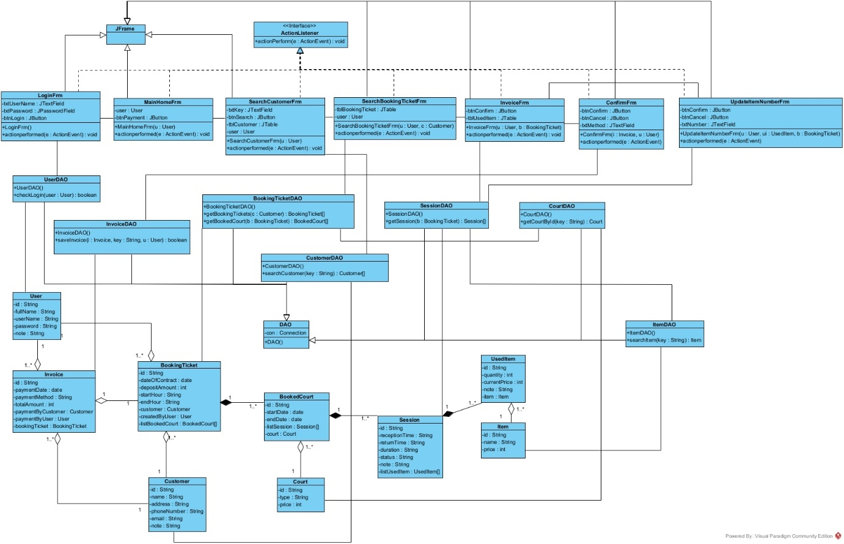
9. Sequence diagram of design phase of the module
- A customer come to make payment
- The receptionist enter username, password and click login button on LoginFrm
- The method actionperformed() of LoginFrm() is called
- The method actionperformed() calls User to create an User object
- The class User packs the information into an User object
- The class User returns User object to the method actionperformed().
- The method actionperformed() calls method checkLogin() of the class UserDAO
- The method checkLogin() checks the login information
- The method checkLogin() calls the class User set two more attributes: name, role
- The class User calls its method setName(), setRole()
- The class User returns the User object to the method checkLogin()
- The method checkLogin() returns the results to the actionPerformed()
- The method actionPerformed() calls the class MainHomeFrm
- The constructor MainHomeFrm() is called
- The interface MainHomeFrm is shown to the receptionist
- The receptionist clicks on the customer paying button
- The method actionperformed() of the class MainHomeFrm is called
- The method actionPerformed() calls the class SearchCustomerFrm
- The constructor SearchCustomerFrm() is called
- The interface SearchCustomerFrm is shown to the receptionist
- The receptionist asks the customer about their name
- The customer responds with their name
- The receptionist enter their name into the name field and click search
- The method actionperformed() is called
- The method actionPerformed() calls the method searchCustomer() of the class CustomerDAO
- The method searchCustomer() is executed
- The method searchCustomer() calls the class Customer to pack the results
- The class Customer pack each result into a Customer object
- The class Customer returns the object to the method searchCustomer()
- The method searchCustomer() returns the list of Customer object to the method actionperformed()
- The method actionperformed() displays the results on the interface SearchCustomerFrm to the receptionist
- The receptionist asks for the customer phone number
- The customer responds with their phone number
- The receptionist clicks on the correct customer
- The method actionperformed() of the class SearchCustomerFrm is called
- The method actionperformed() calls the constructor SearchBookingTicketFrm() of the class SeacrhBookingTicket
- The constructor SearchBookingTicketFrm() is called
- The constructor SearchBookingTicketFrm() calls the method getBookingTickets() of the class BookingTicketDAO
- The method getBookingTickets() of the class BookingTicketDAO is executed
- The method getBookingTickets() call the method getBookedCourt()
- The method getBookedCourt() is executed
- The method getBookedCourt() call the method getCourtById() of the class CourtDAO
- The method getCourtById() is executed
- The method getCourtById() call the class Court to pack the result
- The class Court pack the result to a Court object
- The class Court return the Court object to the method getCourtById()
- The method getCourtById() return the Court object to the method getBookedCourt()
- The method getBookedCourt() call the class BookedCourt to pack the results
- The class BookedCourt pack each results into a BookedCourt object
- The class BookedCourt return the BookedCourt object to the method getBookedCourt()
- The method getBookingTicket() calls the class BookingTicket() to pack the results
- The class BookingTicket pack each result into a BookingTicket object
- The class BookingTicket returns the BookingTicket object to the method getBookingTicket()
- The method getBookingTicket() returns list of BookingTicket object to the contructor SearchBookingTicketFrm()
- The constructor SearchBookingTicketFrm() displays the results on the interface SearchBookingTicketFrm to the receptionist
- The receptionist then asks the customer which booking ticket they want to make payment for
- The customer responds with the booking ticket they want to make payment for
- The receptionist click the correct booking ticket
- The method actionperformed() of the class SearchBookingTicketFrm is called
- The method actionperformed() call the constructor InvoiceFrm() of the class InvoiceFrm
- The contructor InvoiceFrm() is called
- The contructor InvoiceFrm() call the method getSession() of the class SessionDAO()
- The method getSession() is executed
- The method getSession() call the method getUsedItem()
- The method getUsedItem() is called
- The method getUsedItem() call the method searchItem() of the class ItemDAO
- The method searchItem() is executed
- The method searchItem() call the class Item to pack the result
- The class Item pack the result into an Item object
- The class Item return the Item object to the method searchItem()
- The method searchItem() return the result to the getUsedItem() method
- The method getUsedItem() call the class UsedItem to pack the result
- The class UsedItem pack each result into a UsedIem object
- The class UsedItem return the UsedItem object to the method getUsedItem()
- The method getSession() call the class Sesion to pack the result
- The class Session pack each result into a Session object
- The class Session return the Session object to the method getSession()
- The method getSession() return a list of Session object to the constructor InvoiceFrm()
- The constructor InvoiceFrm() displays the results on the interface InvoiceFrm to the receptionist
- The receptionist asks the customer for the confirmation and payment method
- The customer confirms and responds with the payment method
- The receptionist clicks confirm
- The method actionperformed() of the class InvoiceFrm is executed
- The method actionperformed() calls the class ConfirmFrm
- The constructor ConfirmFrm() is called
- The interface ConfirmFrm is shown to the receptionist
- The receptionist enter the payment method and clicks confirm
- The method actionperformed() of the class ConfirmFrm is called
- The method actionperformed() call the method saveInvoice() of the class InvoiceDAO
- The method saveInvoice() is executed
- The method saveInvoice() return the result to the method actionperformed()
- The method actionperformed() display a success message to the receptionist
- The receptionist clicks OK button
- The method actionPerformed() calls the interface MainHomeFrm
- The interface MainHomeFrm is shown to the Customer
- The receptionist confirms the successful payment to the customer

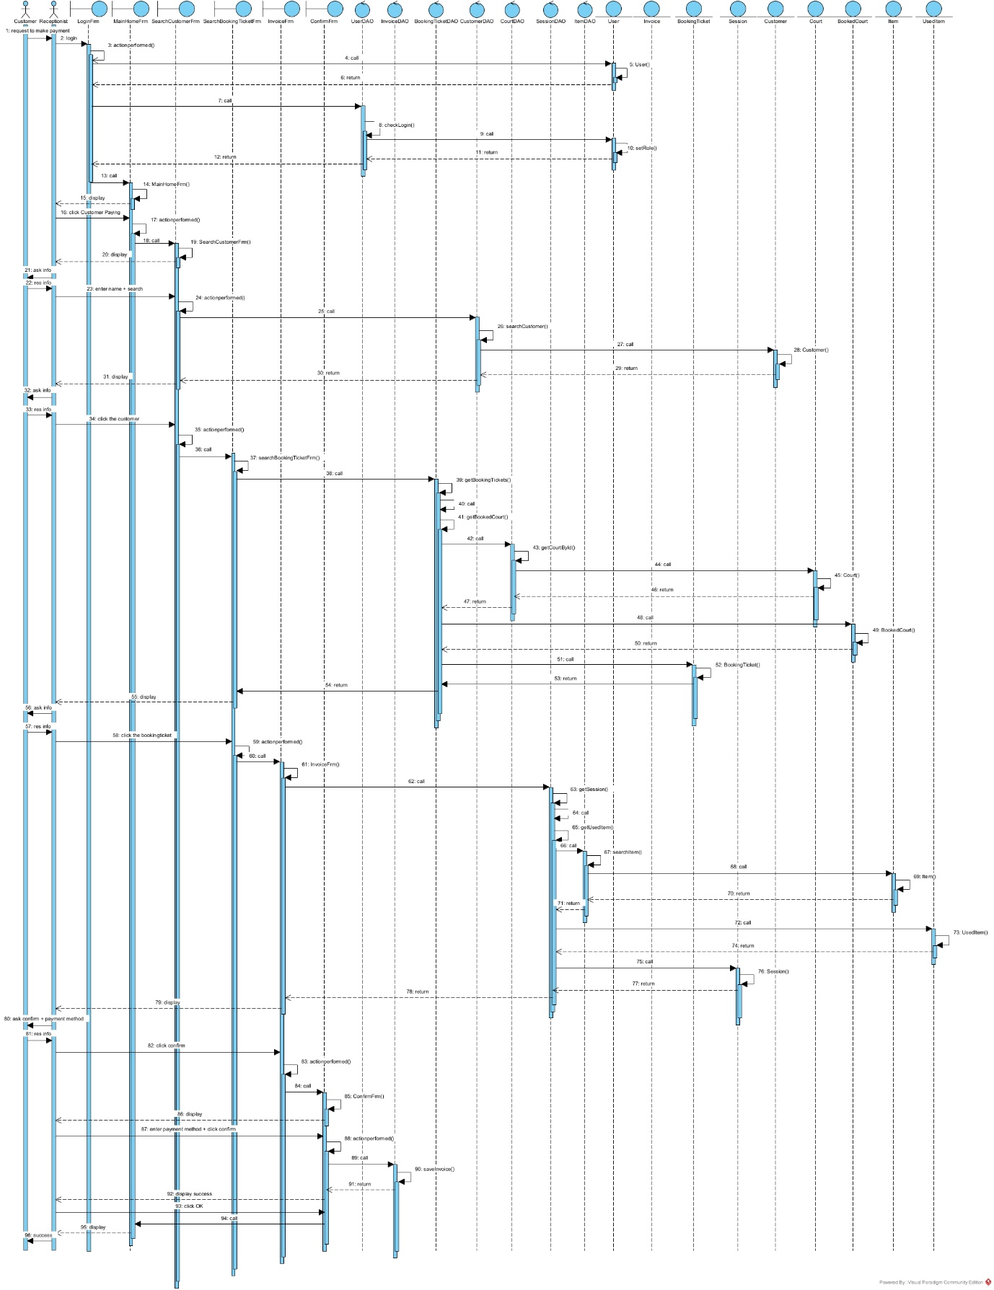

10. Test plan and standard testcase for blackbox testcase of the module
Test plan
No. | Module | Test case
1 | Customer paying | Customer exists, booking ticket exists
2 |  | Customer exists, booking ticket does not exist
3 |  | Customer does not exist, booking ticket exists
4 |  | Customer does not exist, booking ticket does not exist
5 |  | Make payment 2 consecutive times for 1 booking ticket

Test case No. 1
The database before testing:
tblUser:
id | username | password | name | role
1 | a | a | A | receptionist

tblCustomer:
id | name | address | phone | email | note
1 | An | Huynh Thuc Khang | 9172386245 | an@gmail.com
2 | Anh | Lang Ha | 1234685647 | anh@gmail.com
3 | B | Yen Hoa | 1234145613 | b@gmail.com

tblBookingTicket:
id | dateOfContract | depositAmount | CustomerId | UserId
1 | 30/03/2024 | 0 | 1 | 1
2 | 01/04/2024 | 0 | 2 | 1
3 | 20/06/2024 | 0 | 1 | 1

tblCourt:
id | type | price
1 | single | 500.000
2 | single | 500.000

tblBookedCourt:
id | startDate | endDate | startHour | endHour | dayOfWeek | CourtId | BookingTicketIId
1 | 01/04/2024 | 30/06/2024 | 20:00 | 22:00 | Monday | 1 | 1
2 | 01/05/2024 | 31/08/2024 | 14:00 | 16:00 | Friday | 2 | 3
3 | 01/07/2024 | 30/09/2024 | 09:00 | 11:00 | Saturday | 1 | 2

tblRentalSession:
id | receptionTime | returnTime | date | BookedCourtId
1 | 20:00 | 22:00 | 01/04/2024 | 1
2 | 20:00 | 22:00 | 08/04/2024 | 1
3 | 20:00 | 22:00 | 15/04/2024 | 1
4 | 20:00 | 22:00 | 22/04/2024 | 1
5 | 20:00 | 22:00 | 29/04/2024 | 1
6 | 20:00 | 22:00 | 06/05/2024 | 1
7 | 20:00 | 22:00 | 13/05/2024 | 1
8 | 20:00 | 22:00 | 20/05/2024 | 1
9 | 20:00 | 22:00 | 27/05/2024 | 1
10 | 20:00 | 22:00 | 03/06/2024 | 1
11 | 20:00 | 22:00 | 10/06/2024 | 1
12 | 20:00 | 22:00 | 17/06/2024 | 1
13 | 20:00 | 22:00 | 24/06/2024 | 1
14 | 14:00 | 16:00 | 03/05/2024 | 2
15 | 14:00 | 16:00 | 10/05/2024 | 2
16 | 14:00 | 16:00 | 17/05/2024 | 2
17 | 14:00 | 16:00 | 24/05/2024 | 2
18 | 14:00 | 16:00 | 31/05/2024 | 2
19 | 14:00 | 16:00 | 07/06/2024 | 2
20 | 14:00 | 16:00 | 14/06/2024 | 2
21 | 14:00 | 16:00 | 21/06/2024 | 2
22 | 14:00 | 16:00 | 28/06/2024 | 2
23 | 14:00 | 16:00 | 05/07/2024 | 2
24 | 14:00 | 16:00 | 12/07/2024 | 2
25 | 14:00 | 16:00 | 19/07/2024 | 2
26 | 14:00 | 16:00 | 26/07/2024 | 2
27 | 14:00 | 16:00 | 02/08/2024 | 2
28 | 14:00 | 16:00 | 09/08/2024 | 2
29 | 14:00 | 16:00 | 16/08/2024 | 2
30 | 14:00 | 16:00 | 23/08/2024 | 2
31 | 14:00 | 16:00 | 30/08/2024 | 2
32 | 9:00 | 11:00 | 06/07/2024 | 3
33 | 9:00 | 11:00 | 13/07/2024 | 3
34 | 9:00 | 11:00 | 20/07/2024 | 3
35 | 9:00 | 11:00 | 27/07/2024 | 3
36 | 9:00 | 11:00 | 03/08/2024 | 3
37 | 9:00 | 11:00 | 10/08/2024 | 3
38 | 9:00 | 11:00 | 17/08/2024 | 3
39 | 9:00 | 11:00 | 24/08/2024 | 3
40 | 9:00 | 11:00 | 31/08/2024 | 3
41 | 9:00 | 11:00 | 07/09/2024 | 3
42 | 9:00 | 11:00 | 14/09/2024 | 3
43 | 9:00 | 11:00 | 21/09/2024 | 3
44 | 9:00 | 11:00 | 28/09/2024 | 3

tblItem:
id | name | price
1 | Pepsi | 10.000
2 | Revive | 10.000

tblUsedItem:
id | quantity | currentPrice | RentalSessionId | ItemId
1 | 10 | 10.000 | 1 | 1
2 | 5 | 10.000 | 1 | 2
3 | 5 | 10.00 | 2 | 2

tblInvoice:
id | paymentDate | paymentMethod | totalAmount | UserId | CustomerId | BookingTicketId

Testing scenario and expected results:
Scenario | Expected result
1. Login  Enter username=“a”  Password=“a”  Click Login | Main home appear
2. Click Customer Paying | The interface to search customer appear with a text field and a search button
3. Enter Customer name = ‘’An”  Click Search | Interface show list of customer  Customer name = An  Search  No. Name Address Phone Email  1 An Huynh Thuc Khang 9172386245 an@gmail.com  2 Anh Lang Ha 1234685647 anh@gmail.com
4. Click first row | Interface show list of booking ticket of that cutomer  Id Contract Date Deposit  1 30/03/2024 0  2 01/04/2024 0
5. Click first row | Interface show invoice  Invoice  Confirm  Go Back  Customer Information  Name: An  Phone: 9172386245  Email: an@gmail.com  Field Cost  Court Court type Sessions Total Cost  1 single 13 6,500,000 VND  2 single 1 500,000VND  Items used  Session Item Name Quantity Price  1 Pepsi 10 100000  1 Revive 5 50000  2 Revive 5 50000  Field Cost 7,000,000 VND  Items Cost 200,000VND  Total 7,200,000VND
6. Click confirm | A message box appear with field to enter payment method, a cancel and a confirm button  Payment Confirmation  Payment Method:  Cancel  Confirm
7. Enter Payment method = “Cash”  Click confirm | A success message box appear with Ok button
8. Click Ok | Return to the main home interface
The database after testing:
Only one tables change:
tblInvoice:
id | paymentDate | paymentMethod | total | UserId | CustomerId | BookingTicketId
1 | 01/07/2024 | Cash | 7,200,000 | 1 | 1 | 1

